Jinhao Ping

Rice University

**Move over Bootstrap and Foundation**

**Welcome Semantic UI**

**Abstract:**

In my paper, I am going to introduce you three popular front-end frameworks. They are Bootstrap, Foundation and Semantic UI. I will talk about advantages and disadvantages for each of them and then make a comparison among them and also teach you how to pick the right front-end framework for yourself as conclusion.

**Bootstrap 3: The Leading Responsive, Mobile-First Framework**

Nowadays, if you still think in your mind that mobile web design and application development is a very niche industry, you are out of date. Mobile is neither the trend nor the future, it is the present. According to statistics on *Mobithinking*, there are over 1.2 billion mobile web users worldwide. In the United States, 25% of mobile web users are mobile-only which means they rarely use a desktop to access the web. *[1]* So mobile-friendly, responsive websites are not something good-to-haves. Instead, they are must-haves. For those who wonder what responsive design is, responsive web design is a relatively new approach to website design that ensures users have a good viewing experience no matter what type of device they are using. *[3]* If your site is not responsive and optimized for mobile browsing, your bounce rates will rise and your site ranking will drop based on *Google Webmaster Central Blog*. *[2]* And also if your site is not designed to be responsive, you will have to retrofit it, which costs you extra time and money. Here we comes with the Bootstrap framework which is an excellent choice for building a responsive mobile website or application from scratch.

Bootstrap is a front-end framework that builds responsive, mobile-first websites, developed by Mark Otto and Jacob Thornton at Twitter and released as an open source product in August 2011 on Github. In Bootstrap, contents are divided into a maximum of 12 columns and then condensed down to 6, 4, 3 or less depending on the device viewing the site. In order to achieve responsive design, the app will detect the pixel size of the user’s device and then adjust the columns accordingly. The following is a straightforward graph showing you how Bootstrap works. With a mobile-first approach at its core, its grid system forces designers to create sites for small screens, then scale designs up from there. *[4]*

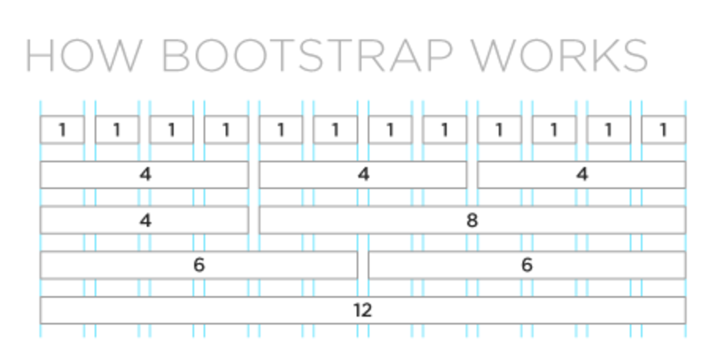

There are many advantages of using Bootstrap. First of the most is that it is easy to use, it uses a mix of HTML5 markup, compiled and minified CSS styling, fonts and JavaScript. Anyone with basic knowledge of HTML and CSS can start using Bootstrap. Undoubtedly, this will also increase the speed of development. If someone wants to push out a new website quickly, definitely Bootstrap is the top choice. Secondly, as I have mentioned above, Bootstrap’s responsive CSS adjusts to phones, tablets and desktops. Thirdly, developing with Bootstrap enforces consistency across programmers regardless of who is working on the project. What’s more, Bootstrap is compatible with all modern browsers such as Chrome, Firefox, Safari and even Internet Explorer.

On the opposite sides, Bootstrap is bloated. Those files generated by Bootstrap are quite large. People may defend this point by say that we can always erase things you do not need here and there. However, this diminishes the purpose of using a framework in the first place. *[5]* Furthermore, because of the strength of Bootstrap that it is constantly under development and the community is very active, you have to face frequent updates and these updates are not always easy to integrate.

Next, I am going to introduce you about Foundation.

**Foundation: The Most Advanced Responsive Front-end Framework**

Foundation, a responsive front-end framework built by a product design company named Zurb, is open source and was released in 2011 under the MIT license. It is quite similar with Bootstrap in many ways such that it can be used for building a responsive website and it is compatible with many browsers.

There are many advantages of using Foundation. First of all, Foundation can be used with completely semantic markup. Since Foundation is built with Compass, it would allow the abstraction of presentation to be easier and faster. There is no need for extraneous IDs, classes or non-semantic empty HTML elements. This way is better in maintainability and reusability. Also Foundation’s code looks much more straightforward than Bootstrap. *[6]* Secondly, it is a true mobile-first philosophy. Foundation is built with small devices as priority. Thirdly, Foundation uses Sass, the finest CSS pre-processor. It makes for a more modular, pragmatic approach to presentation. Sass is a lot more powerful than Less of Bootstrap. Less does have some extensions. However, Less does not have as many awesome frameworks like Compass.

Relatively, Foundation has some drawbacks. Compared to Bootstrap, Foundation has a fewer selection of themes. Also it does not support for Internet Explorer 8, which is bad for some large markets in the third world such as China and India where IE8 is still very popular. Finally, Foundation cannot beat large community support and more choice in the form of plugins and widgets of Bootstrap.

Here we come to introduce Semantic UI.

**Semantic UI: UI Is The Vocabulary Of The Web**

Semantic is a development framework that helps create beautiful, responsive layouts using human-friendly HTML. Just like the Semantic UI Team says, “Semantic empowers designers and developers by creating a shared vocabulary for UI.” Semantic UI is a new player on the field of HTML/CSS frameworks, but it is coming in strong. *[7]*

There are a lot of good features that Semantic UI brings to us. First of all, Semantic is designed completely with EM. Everything is defined using em and rem in this way that components could be resized simply on the fly. All you need to do is to change using a media query. Secondly, Semantic is easy to learn because it uses simply, common language for parts of interface elements and familiar patterns found in natural languages for describing elements*. [8]* Thirdly, Semantic has a high-level theming with 3000+ theming variables. All UI components share site-wide defaults. This lets you change the look and feel of components quickly and gives you complete design freedom.

However, Semantic UI is pretty new and still under development. People may not want to use it for large projects, which depend on huge resources and support from community. Furthermore, JavaScript is an essential skill to develop website interfaces using Semantic UI. Almost all features will not work without writing JavaScript scripts such as modal window and dropdown.

**Evaluation:**

In my mind, Bootstrap provides CSS, JavaScript and font files. In good way, this leads less time to start. However, for small and medium size projects just like our Ricebook, we will never use a full list of all components. This is very no good for development. On the other hand, Semantic UI components are much more difficult than Bootstrap, especially in the installation process. It includes more than 20 themes in its basic package.

In terms of speed of coding, Bootstrap and Foundation both have some classes with names that are easily misunderstood such as this one. *[9]*

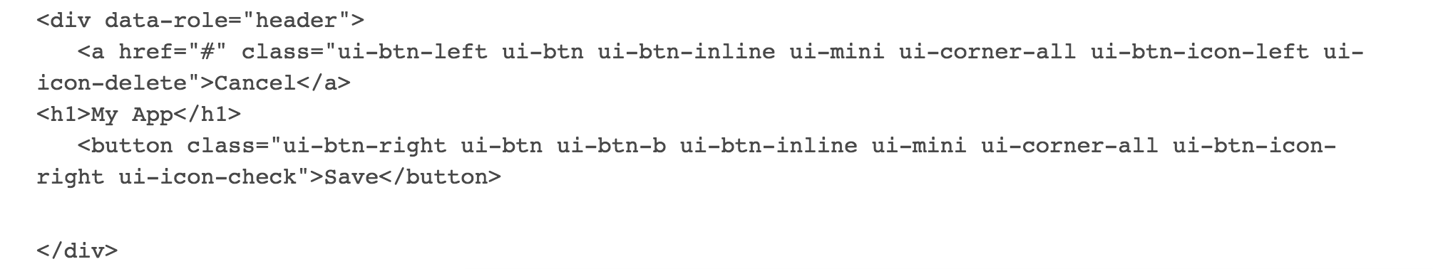

Compared to Bootstrap, Semantic-UI’s CSS manages to be even user-friendly than Bootstrap and Foundation, with CSS that’s easier for developers to read by resembling a more semantic language – hence its name.

To wrap up, each of the three front-end frameworks has their own advantages and disadvantages. As I have mentioned above, for Bootstrap, it is better for beginners to start with. It has a large supporting community to discuss problems. However, it contains large files, which may not be necessary to use and hard for updating versions. For Foundation, it is very good for mobile-first development. Codes look more straightforward, however, it has fewer themes that are provided to pick from and Foundation does not support for Internet Explorer 8. For Semantic UI, it looks more modern and contains much more themes than the others, but it may not be that intuitive for beginners who are lack of sufficient JavaScript knowledge. Also it has a smaller community compared to the other two. You may consider this before using it for large projects, which require some community supports.

**Conclusion:**

In my point of view, all of the front-end framework can save you weeks of development time. They can all set up mobile-friendly, responsive applications or websites. For choosing between Bootstrap and Foundation depends entirely on how familiar you are with the framework. If speed and stability plays more important role in your project, you should go for Bootstrap. On the other hand, if you think flexibility is more significant to you, go pick Foundation. For Semantic UI, which does look more modern, but you need to know certain of JS in order to occupy it. If you are a junior front-end developer, I think you will fall in love with Bootstrap. Instead, if you were an experienced developer, you would definitely prefer Semantic UI.

**Reference:**

*[1] Mobile First Design: Why It’s Great and Why it Sucks posted by CMV Blog* [*https://codemyviews.com/blog/mobilefirst*](https://codemyviews.com/blog/mobilefirst)

*[2] Google Webmaster Central Blog: Finding more mobile-friendly search results* [*https://webmasters.googleblog.com/2015/02/finding-more-mobile-friendly-search.html*](https://webmasters.googleblog.com/2015/02/finding-more-mobile-friendly-search.html)

*[3] What Is Responsive Web Design & Why Do You Need It?* [*https://www.upwork.com/hiring/mobile/what-is-responsive-web-design/*](https://www.upwork.com/hiring/mobile/what-is-responsive-web-design/)

*[4] Bootstrap 3: The Leading Responsive, Mobile-First Framework* [*https://www.upwork.com/hiring/development/bootstrap-3-front-end-framework-responsive-mobile-first-sites/*](https://www.upwork.com/hiring/development/bootstrap-3-front-end-framework-responsive-mobile-first-sites/)

*[5] The Bootstrap Framework Controversy … Should You Use It or Not?*

[*http://www.htmlcenter.com/blog/the-bootstrap-framework-controversy-should-you-use-it-or-not/*](http://www.htmlcenter.com/blog/the-bootstrap-framework-controversy-should-you-use-it-or-not/)

*[6] Top 10 reasons to use Zurb’s Foundation framework*

[*http://www.zingdesign.com/top-10-reasons-to-use-zurbs-foundation-framework/*](http://www.zingdesign.com/top-10-reasons-to-use-zurbs-foundation-framework/)

*[7] Move over Bootstrap and Foundation, welcome Semantic UI*

[*https://coderwall.com/p/ham3gg/move-over-bootstrap-and-foundation-welcome-semantic-ui*](https://coderwall.com/p/ham3gg/move-over-bootstrap-and-foundation-welcome-semantic-ui)

*[8] What’s Different – Separating Semantic from the pack*

[*http://learnsemantic.com/preface/whats-different.html*](http://learnsemantic.com/preface/whats-different.html)

*[9] Twitter Bootstrap vs. Semantic UI*

[*https://www.upwork.com/hiring/development/twitter-bootstrap-vs-semantic-ui/*](https://www.upwork.com/hiring/development/twitter-bootstrap-vs-semantic-ui/)